CSA1707-ARTIFICIAL INTELLIGENCE LAB EXPERIMENTS
Name: J O Joanna Divine
Reg No: 192572003

Program 1 : Python Program to Solve 8. Puzzle Problem Aim
To develop a Python program that solves the 8-Puzzle Problem using a search algorithm (such as Breadth-First Search - BFS) to find the shortest sequence of moves from the initial state to the goal state.

Algorithm
- Represent the puzzle as a 3×3 matrix.
- Define the goal state.
- Locate the empty tile (0).
- Generate all possible moves (up, down, left, right).
- Use Breadth-First Search (BFS) to explore possible states.
- Keep track of visited states to avoid repeated exploration.
- If the goal state is reached, display the solution path.
- If all possibilities are exhausted, report that no solution exists.

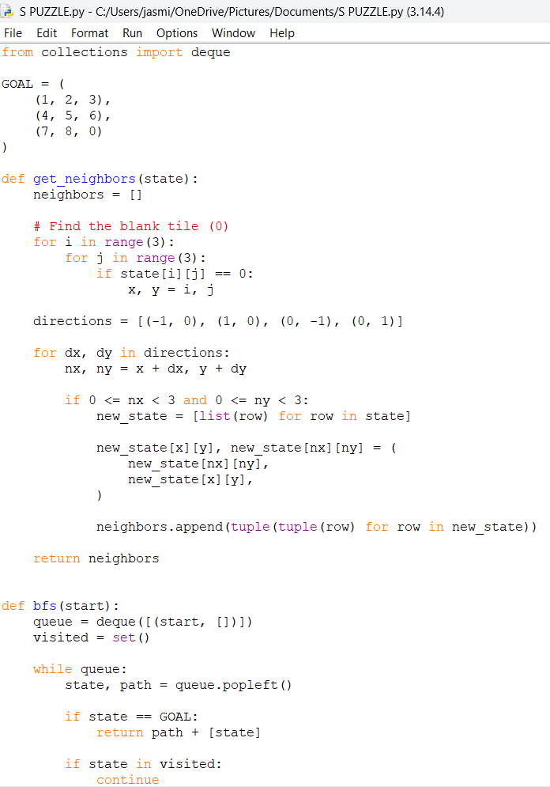
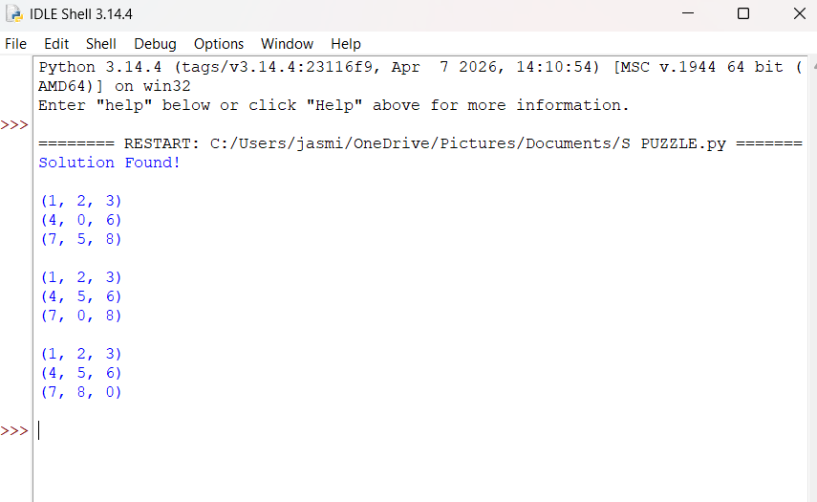

RESULT
Thus, the 8-Puzzle Problem solved successfully using Python.

Program 2: Python Program to Solve 8 Queen Problem
Aim
To develop a Python program to solve the 8-Queen Problem using the Backtracking Algorithm, such that no two queens attack each other on an 8×8 chessboard.

Algorithm
- Create an empty 8×8 chessboard.
- Start placing queens row by row.
- Before placing a queen, check whether the position is safe:
  - No queen exists in the same column.
  - No queen exists in the left diagonal.
  - No queen exists in the right diagonal.
- If the position is safe, place the queen.
- Recursively place queens in the next row.
- If no safe position is found, backtrack by removing the previously placed queen.
- Continue until all 8 queens are successfully placed.
- Display the final chessboard configuration.

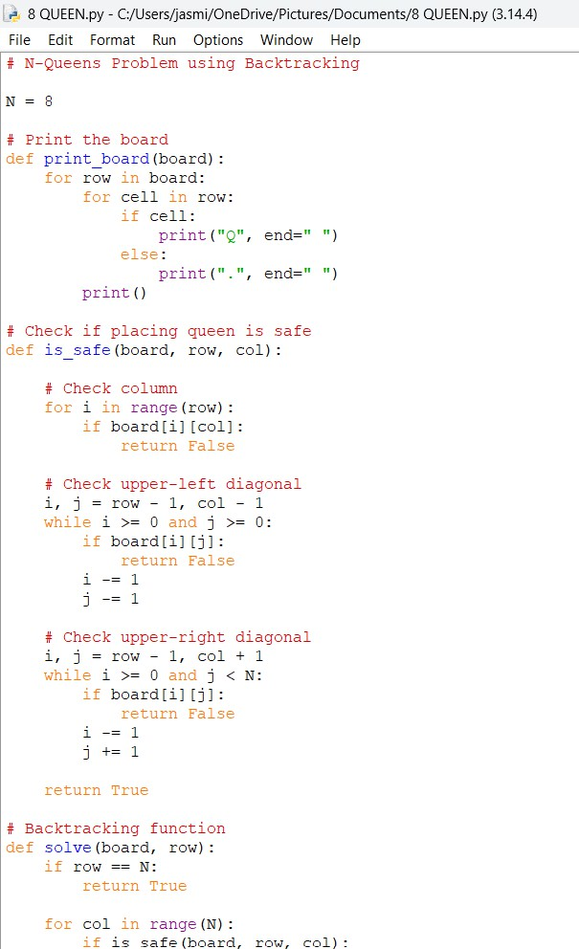

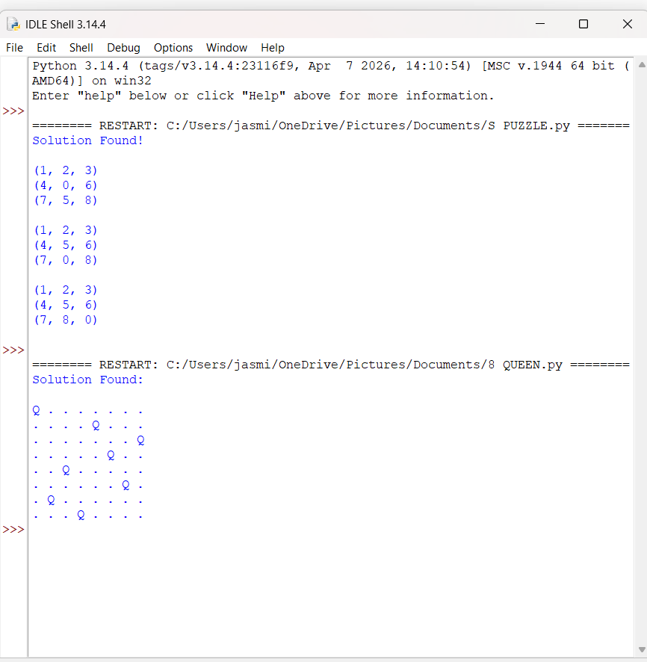

RESULT:
Thus, the 8-Queen Problem was solved successfully using Python.

Program 3: Water Jug Problem using Python Aim
To solve the Water Jug Problem using state-space search.

Algorithm
- Start.
- Initialize the capacities of Jug 1, Jug 2, and the target amount.
- Create the initial state (0, 0).
- Create an empty queue and insert the initial state.
- Create an empty set to store visited states.
- While the queue is not empty:
  - Remove the front state from the queue.
  - If the state is already visited, continue to the next state.
  - Mark the current state as visited.
  - If either jug contains the target amount, print the solution path and stop.
  - Generate the following successor states:
    - Fill Jug 1.
    - Fill Jug 2.
    - Empty Jug 1.
    - Empty Jug 2.
    - Pour water from Jug 1 to Jug 2.
    - Pour water from Jug 2 to Jug 1.

  - Add all unvisited successor states to the queue.
- If the queue becomes empty, print "No Solution".
- Stop.

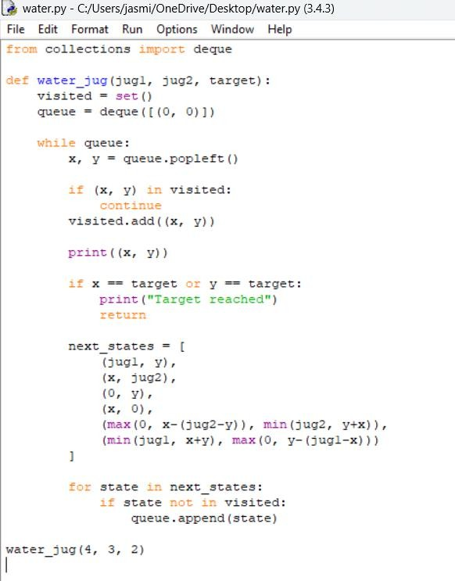

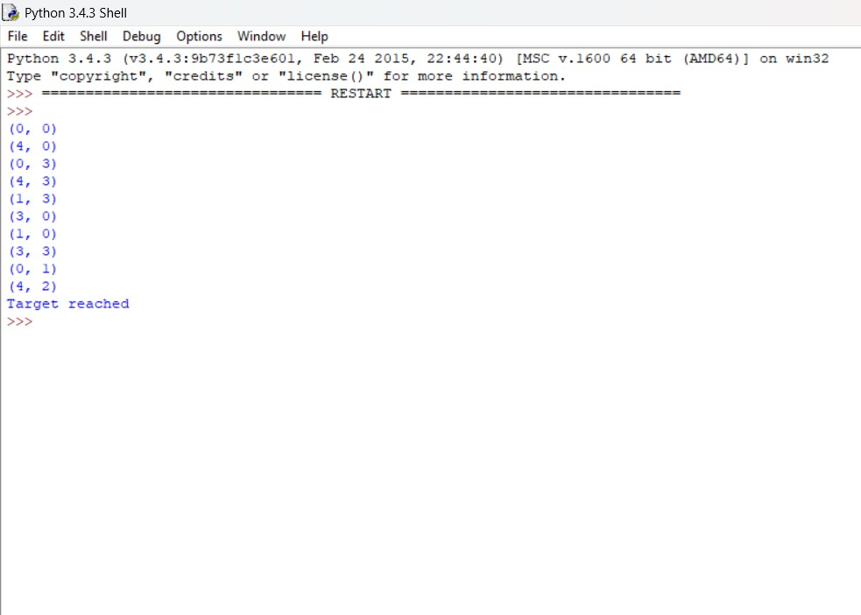

Result :
Thus, the Water Jug Problem was solved successfully using Python.

Program 4: Missionaries and Cannibals Problem Aim:
To solve the Missionaries and Cannibals problem using State Space Search in Python.

Algorithm:
- Start with the initial state (3, 3, Left Bank).
- Create a queue and insert the initial state.
- Create a set to store visited states.
- Remove the front state from the queue.
- If it is the goal state (0, 0, Right Bank), print the solution path and stop.
- Generate all possible boat moves:
  - Two missionaries
  - Two cannibals
  - One missionary
  - One cannibal
  - One missionary and one cannibal
- For each generated state:
  - Check whether the state is valid (missionaries are never outnumbered by cannibals on either bank).
  - If valid and not visited, add it to the queue.
- Repeat Steps 4–7 until the goal state is reached.
- Display the sequence of states from the initial state to the goal state.

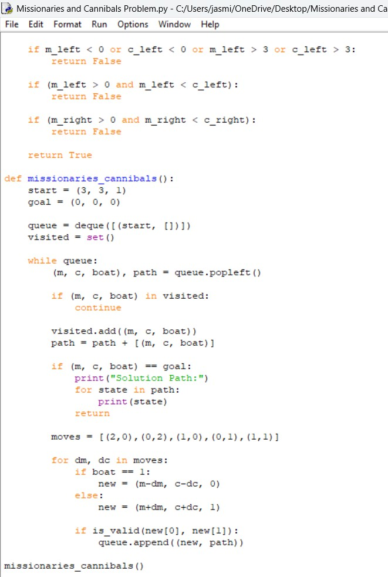

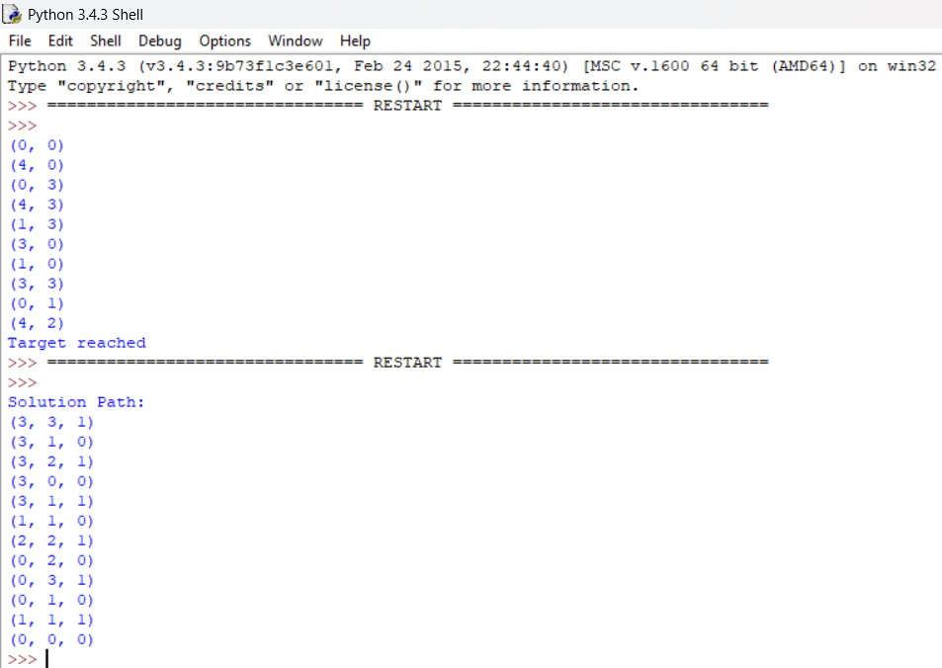

Result
Thus, the Missionaries and Cannibals Problem was successfully solved using State Space Search (Breadth-First Search) in Python.

Program 5: Vacuum Cleaner Problem using Python Aim
To implement the Vacuum Cleaner Problem using Python and clean all dirty rooms.

Algorithm
- Start.
- Initialize the environment with rooms and their states (Clean or Dirty).
- Set the vacuum cleaner's initial position.
- Check the current room.
- If the current room is dirty, clean it.
- Move the vacuum cleaner to the next room.
- Repeat Steps 4–6 until all rooms have been visited.
- Display the final state of all rooms.
- Stop.

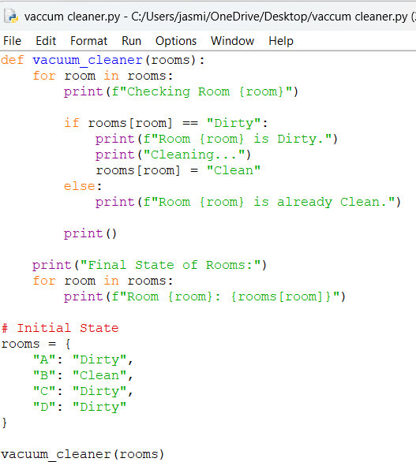
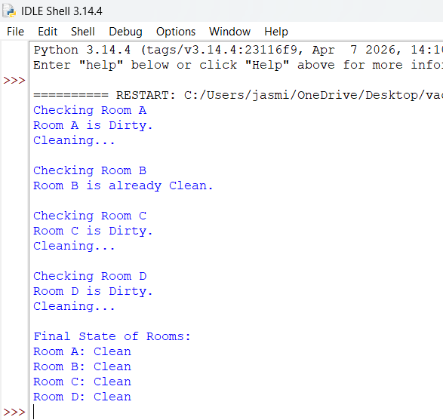

Result
Thus, the Vacuum Cleaner Problem was successfully using the python.

Program 6: Breadth-First Search (BFS)
AIM
To implement Breadth-First Search (BFS) in Python to traverse all the vertices of a graph level by level using a queue.
ALGORITHM
- Start with a graph and select the starting vertex.
- Create an empty visited set to store visited vertices.
- Create a queue and insert the starting vertex.
- Mark the starting vertex as visited.
- Repeat until the queue is empty:
  - Remove the front vertex from the queue.
  - Display the vertex.
  - Check all its adjacent vertices.
  - If an adjacent vertex is not visited, mark it visited and add it to the queue.
- Stop when the queue becomes empty.

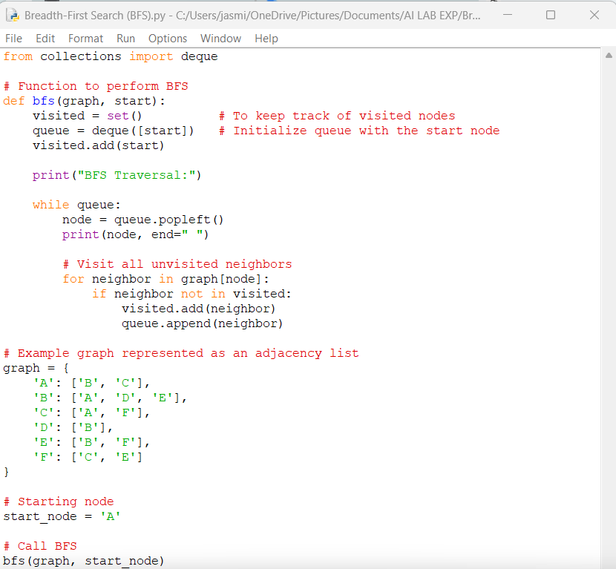
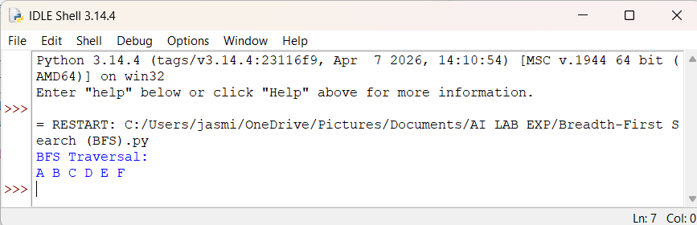
RESULT
The BFS program was successfully implemented in Python. The graph was traversed level by level.

Program 7: Depth-First Search (DFS)
AIM
To implement Depth-First Search (DFS) in Python to traverse all the vertices of a graph by exploring as far as possible along each branch before backtracking.
ALGORITHM
- Start with a graph and select the starting vertex.
- Create an empty visited set.
- Mark the starting vertex as visited.
- Display the starting vertex.
- Visit each adjacent vertex that has not been visited.
- Recursively apply DFS to the unvisited adjacent vertex.
- Continue until all reachable vertices are visited.
- Stop the traversal.

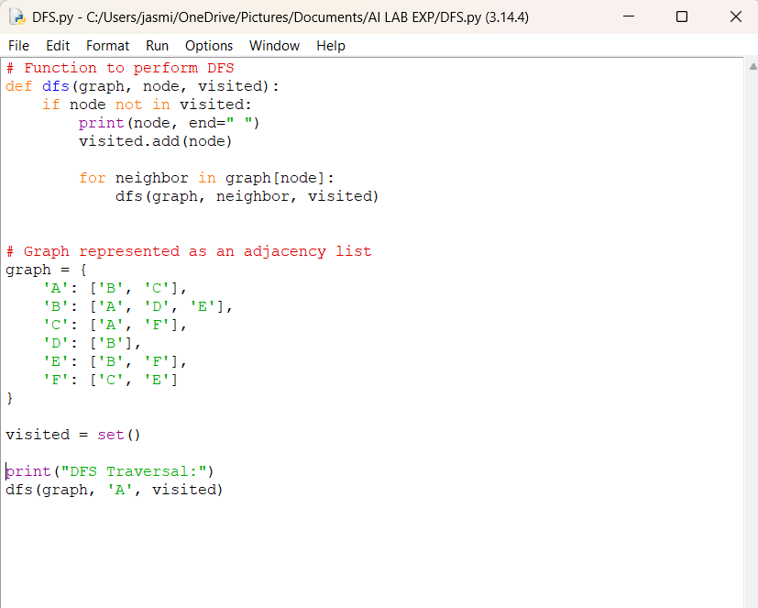
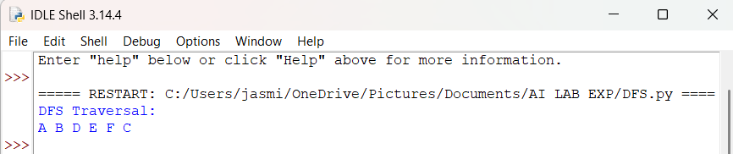

RESULT
The Depth-First Search (DFS) algorithm was successfully implemented in Python, and the graph was traversed by exploring each branch deeply before backtracking.
Program 8: Travelling Salesman Problem (TSP)
AIM
To implement the Travelling Salesman Problem (TSP) using the Brute Force / Exhaustive Search approach in Python and find the minimum-cost route that visits every city exactly once and returns to the starting city.
ALGORITHM
- Start with a set of cities and their distance/cost matrix.
- Select the first city as the starting city.
- Generate all possible permutations of the remaining cities.
- For each permutation:
  - Calculate the total distance of the tour.
  - Add the distance from the last city back to the starting city.
- Compare the total distances of all possible tours.
- Select the tour with the minimum distance.
- Display the shortest route and its minimum cost.
- Stop.

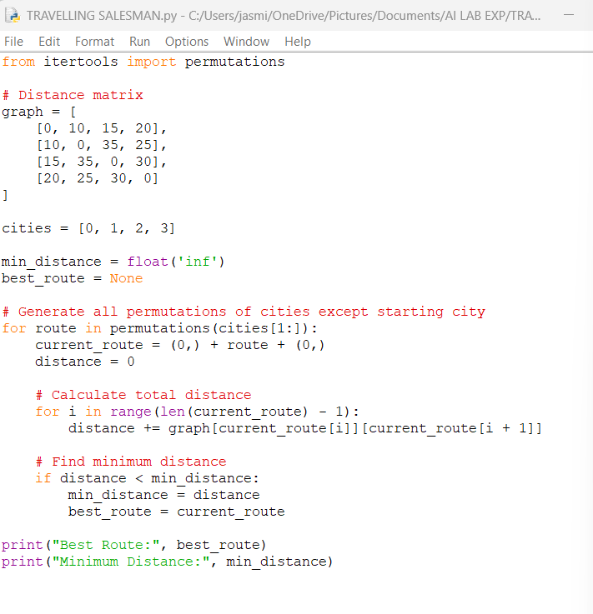
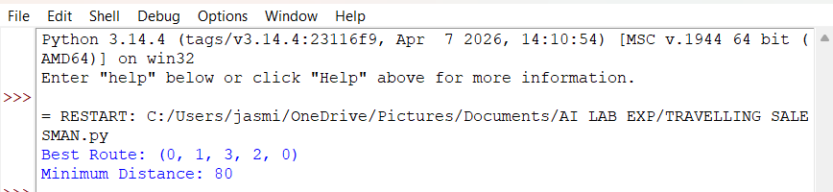

RESULT
The Travelling Salesman Problem was successfully implemented using the Brute Force approach, and the minimum-cost tour was found as A → B → D → C → A, with a total distance of 80.
Program 9: A*Algorithm
AIM
To implement the Travelling Salesman Problem (TSP) using the Brute Force / Exhaustive Search approach in Python and find the minimum-cost route that visits every city exactly once and returns to the starting city.
ALGORITHM
- Start with a set of cities and their distance/cost matrix.
- Select the first city as the starting city.
- Generate all possible permutations of the remaining cities.
- For each permutation:
  - Calculate the total distance of the tour.
  - Add the distance from the last city back to the starting city.
- Compare the total distances of all possible tours.
- Select the tour with the minimum distance.
- Display the shortest route and its minimum cost.
- Stop.

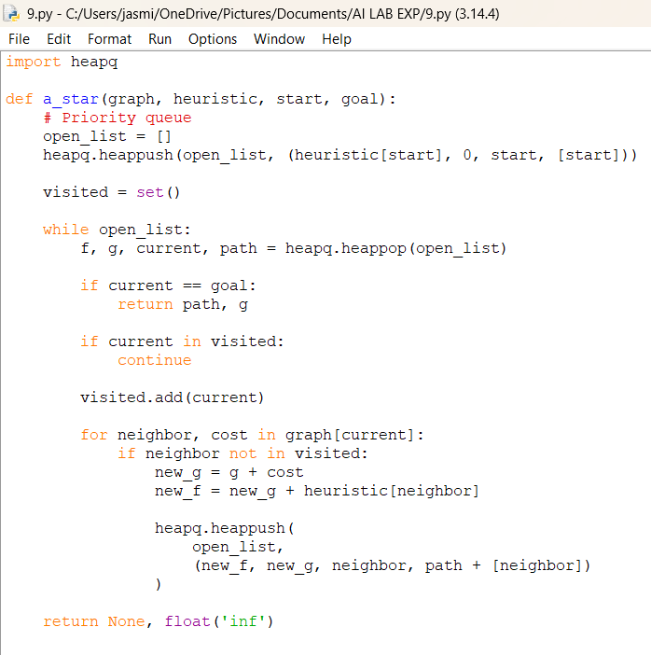
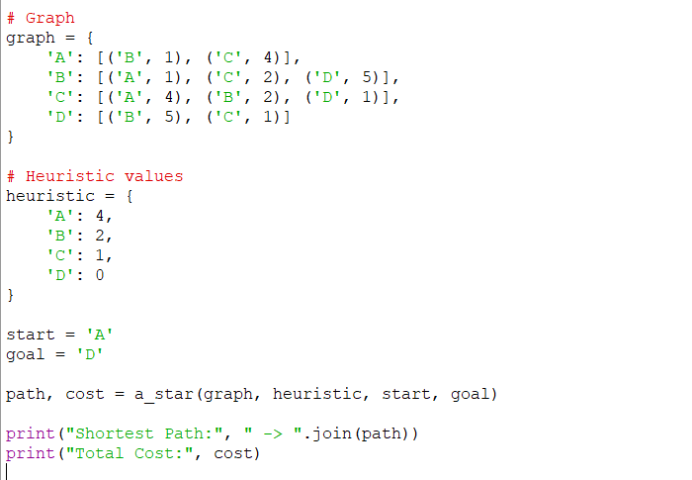
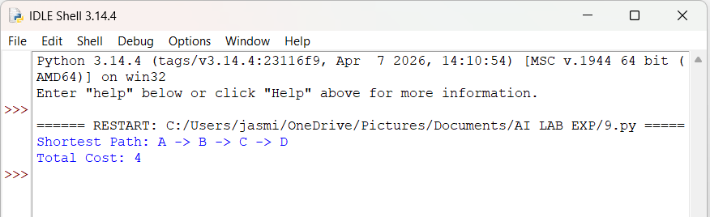

RESULT
The A* Search Algorithm was successfully implemented in Python. The shortest path from A to D was found as:
A → B → C → D
with a total cost of 4.
Program 10: Map Colouring Problem using Constraint Satisfaction Problem (CSP)
AIM
To implement the Map Colouring Problem using Constraint Satisfaction Problem (CSP) in Python, where adjacent regions are assigned different colors.
ALGORITHM
- Define the regions of the map as variables.
- Define the available colors as the domain for each region.
- Define the constraints such that adjacent regions cannot have the same color.
- Select an uncolored region.
- Assign a color from its domain.
- Check whether the assignment satisfies all constraints.
- If valid, continue with the next region.
- If invalid, try another color.
- If no color is possible, backtrack to the previous region.
- Continue until all regions are colored.
- Display the valid map coloring.

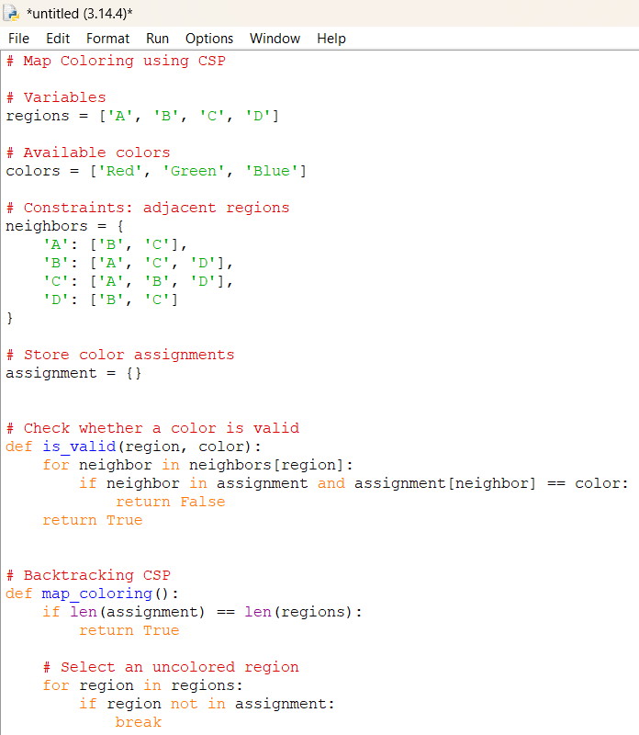
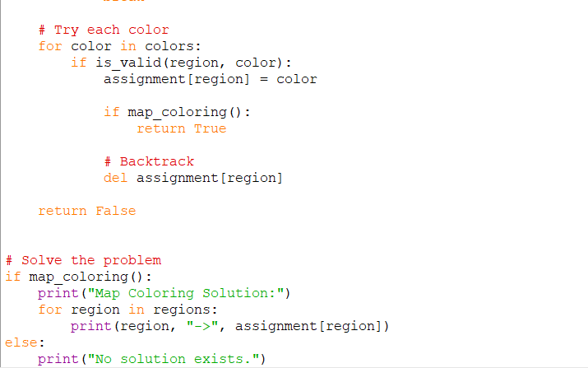
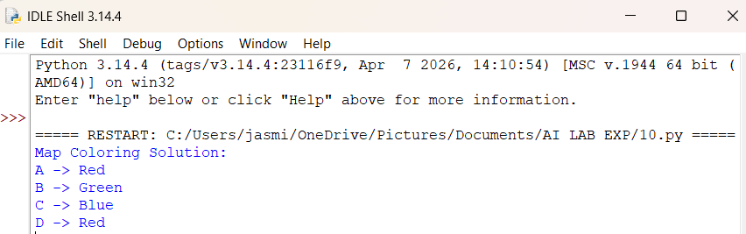

RESULT
The Map Coloring Problem was successfully implemented using the Constraint Satisfaction Problem (CSP) approach. All adjacent regions were assigned different colors while satisfying the given constraints.

Program 11: Tic-Tac-Toe game
AIM
To implement a Tic-Tac-Toe game in Python where two players can play against each other by placing X and O on a 3×3 game board.
ALGORITHM
- Create a 3×3 board and initialize all positions as empty.
- Display the board.
- Set the first player as X.
- Ask the current player to enter a position from 1 to 9.
- Check whether the selected position is empty.
- Place the player's symbol in that position.
- Check whether the player has three symbols in a row, column, or diagonal.
- If a player wins, display the winner and stop the game.
- If all positions are filled and nobody wins, declare the game as a draw.
Otherwise, switch to the other player and repeat the process.

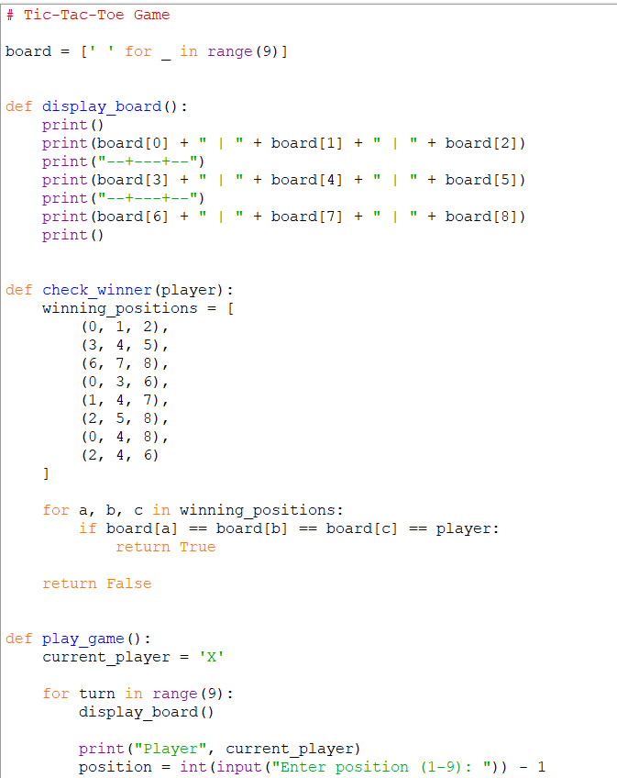
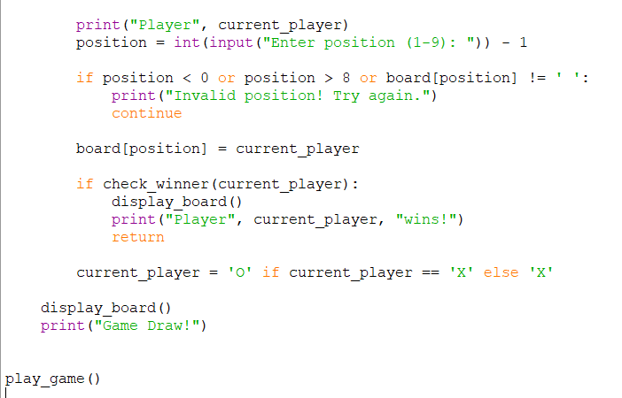

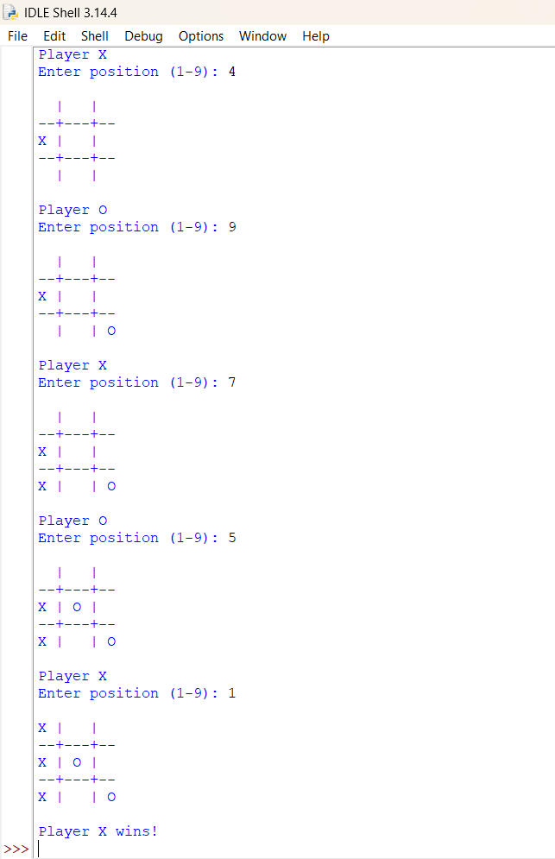
RESULT
The Tic-Tac-Toe game was successfully implemented in Python. The program allows two players to play alternately, checks for winning combinations, and identifies a winner or draw.
Program 12: Minimax Algorithm for Gaming
AIM
To implement the Minimax Algorithm for Gaming in Python and use it to determine the best possible move for a player in a Tic-Tac-Toe game.
ALGORITHM
- Create a 3×3 Tic-Tac-Toe board.
- Define the possible winning combinations.
- Check whether the current board is a win, loss, or draw.
- Generate all possible moves.
- For each possible move:
  - Make the move.
  - Recursively call the Minimax function.
  - Undo the move.
- For the MAX player, select the move with the highest score.
- For the MIN player, select the move with the lowest score.
- Continue until a terminal state is reached.
- Return the best move and its score.
- Display the best move selected by the Minimax algorithm.

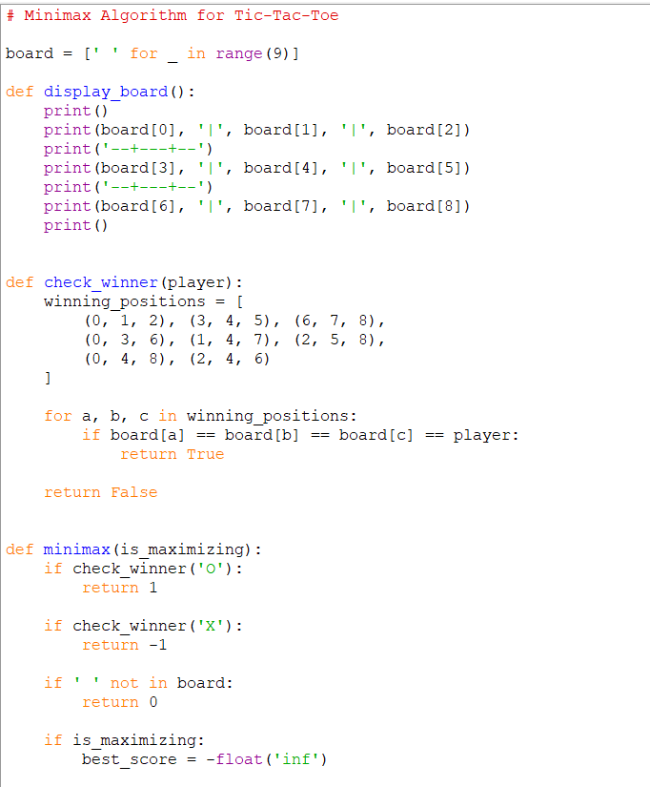
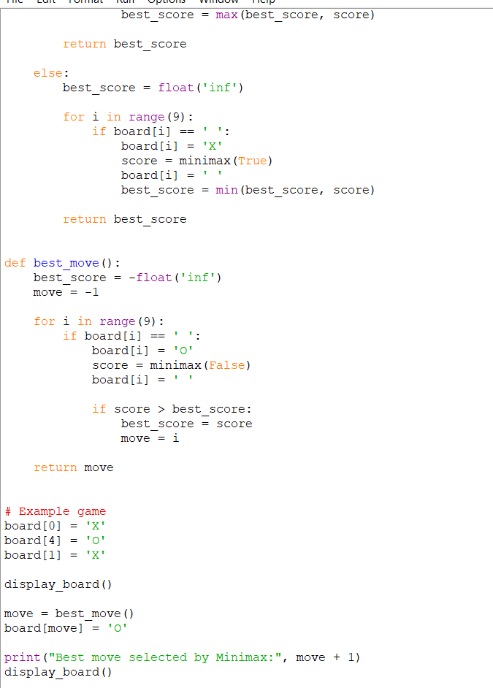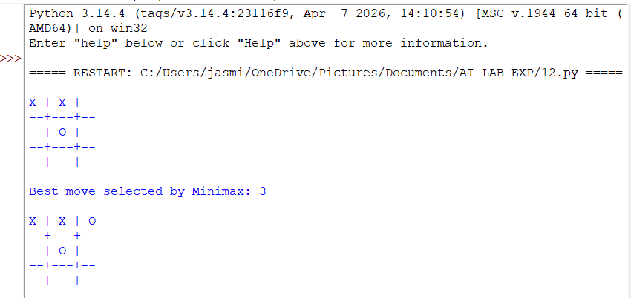

RESULT
The Minimax Algorithm was successfully implemented for gaming. The algorithm evaluates all possible future moves and selects the optimal move for the computer player in the Tic-Tac-Toe game.
Program 13: Alpha-Beta Pruning Algorithm for Gaming

AIM
To implement the Alpha-Beta Pruning Algorithm for Gaming in Python and improve the Minimax algorithm by eliminating branches that do not need to be evaluated.

ALGORITHM
- Initialize the game board.
- Define the winning conditions.
- Start the Alpha-Beta algorithm with:
  - alpha = -∞
  - beta = +∞
- Generate all possible moves.
- For the MAX player, select the move with the highest score.
- Update alpha with the maximum value found.
- For the MIN player, select the move with the lowest score.
- Update beta with the minimum value found.
- If alpha >= beta, stop evaluating the remaining branches (pruning).
- Continue until a winning, losing, or draw state is reached.
- Select and display the best move.

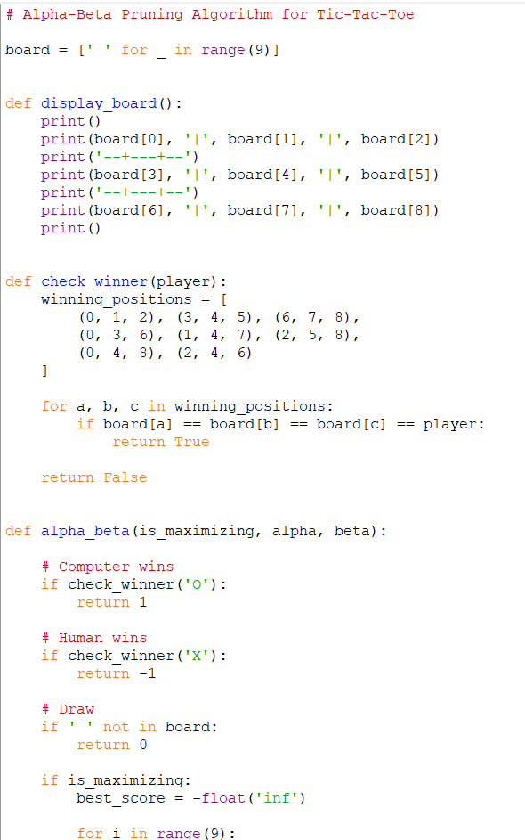
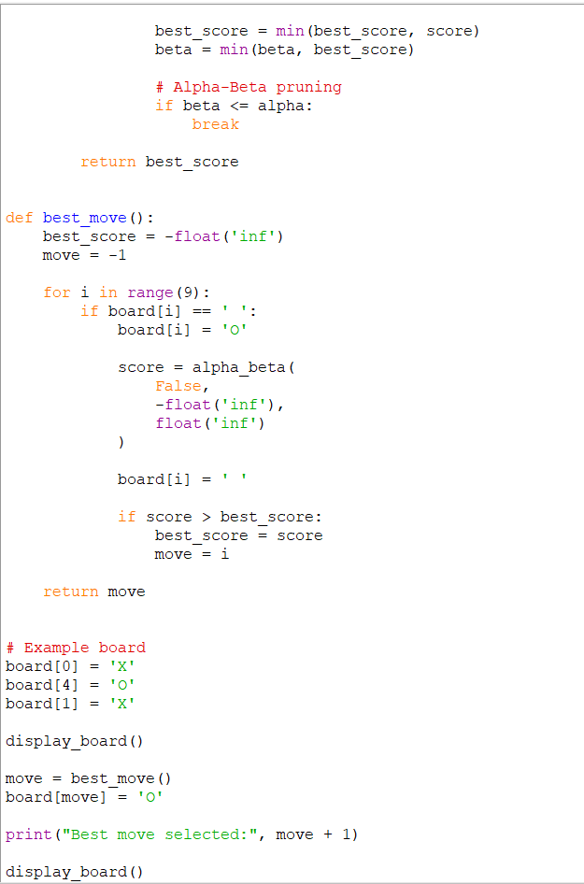
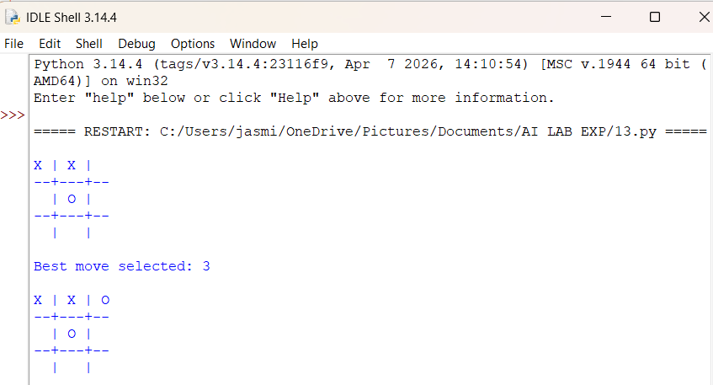

RESULT
The Alpha-Beta Pruning Algorithm was successfully implemented for gaming. It finds the optimal move like Minimax while pruning unnecessary branches, reducing the number of game states that need to be evaluated.

Program 14: Decision Tree Classification algorithm

AIM
To implement a Decision Tree Classification algorithm in Python and classify data based on different feature conditions.

ALGORITHM
- Import the required libraries.
- Create a dataset containing features and target classes.
- Separate the input features (X) and target variable (y).
- Create a Decision Tree Classifier.
- Train the model using the dataset.
- Give a new input sample to the trained model.
- Predict the class of the new sample.
- Display the predicted result.

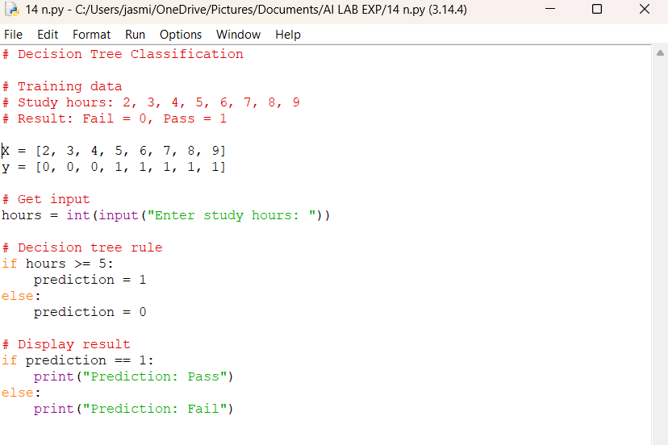
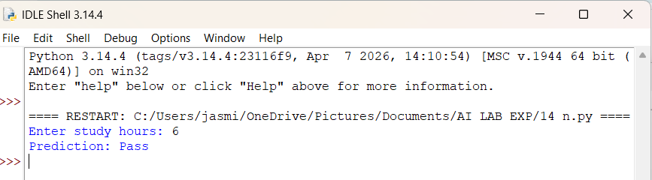

RESULT
The Decision Tree Classification algorithm was successfully implemented in Python. The trained decision tree classified the given student data and predicted Pass based on study hours and attendance.

Program 15: Feed Forward Neural Network (FFNN)

AIM
To implement a Feed Forward Neural Network (FFNN) in Python and use it to classify input data.

ALGORITHM
- Import the required libraries.
- Create the input dataset and corresponding output labels.
- Create a Feed Forward Neural Network.
- Define the input layer, hidden layer, and output layer.
- Train the neural network using the training data.
- Provide a new input value to the trained network.
- Predict the output.
- Display the predicted result.

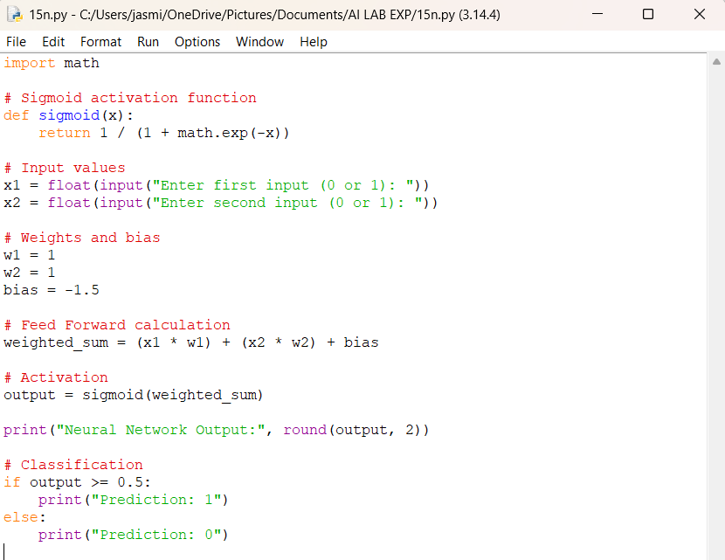
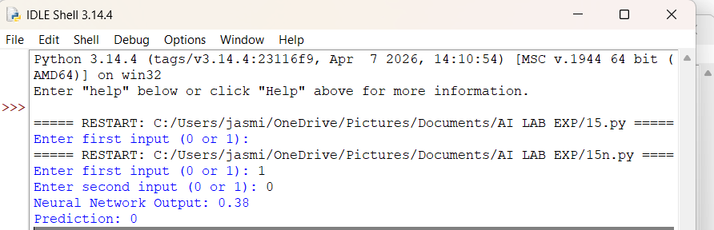

RESULT
The Feed Forward Neural Network was successfully implemented in Python and correctly predicted the output for the given input values.

Program 17: Find the sum of integers from 1 to N.

AIM
To write a Prolog program to find the sum of integers from 1 to N.

ALGORITHM
- Start.
- Read the value of N.
- Initialize sum = 0.
- Repeat from 1 to N.
- Add each integer to sum.
- Display the final sum.
- Stop.

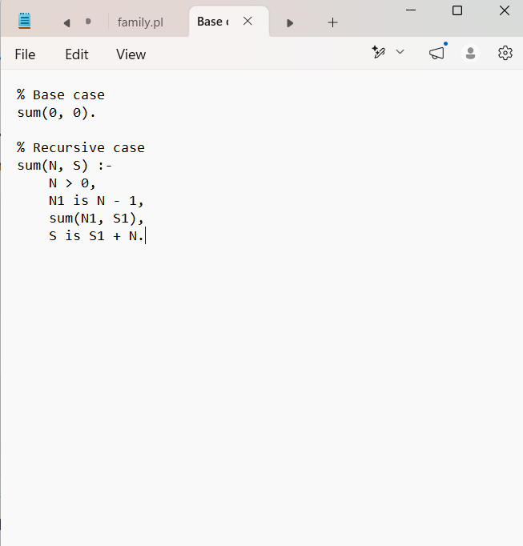
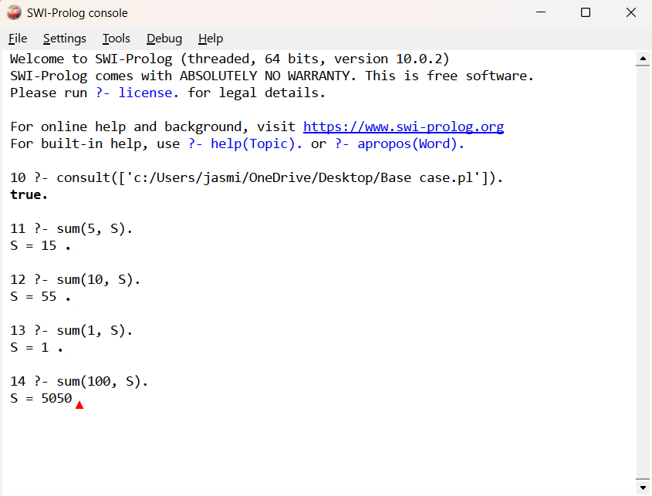

RESULT
The Prolog program was successfully implemented to calculate the sum of integers from 1 to N.

Program 18: Name and Date of Birth (DOB)

AIM
To create a database containing Name and Date of Birth (DOB) and display the stored records.

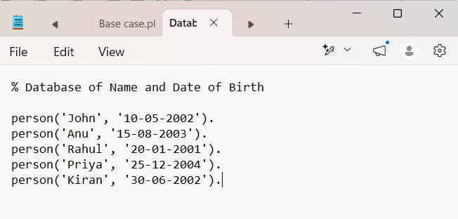
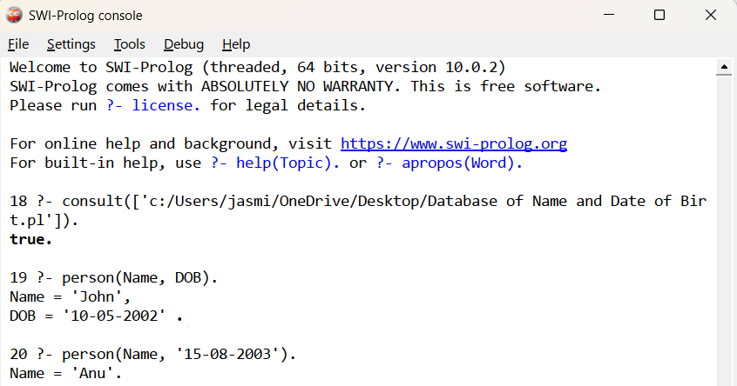
RESULT
The database was successfully created with Name and DOB fields, and the entered record was successfully stored and displayed.

Program 19: students, teachers, and subjects

AIM
To implement a Prolog program to represent the relationship between students, teachers, and subjects and display the subject and teacher corresponding to a given student.

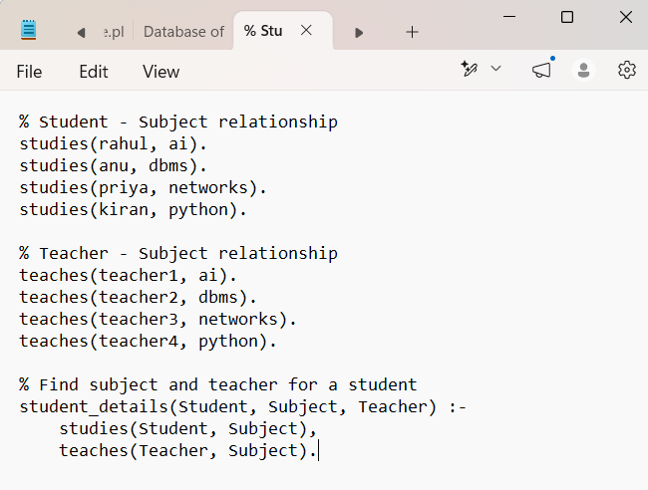 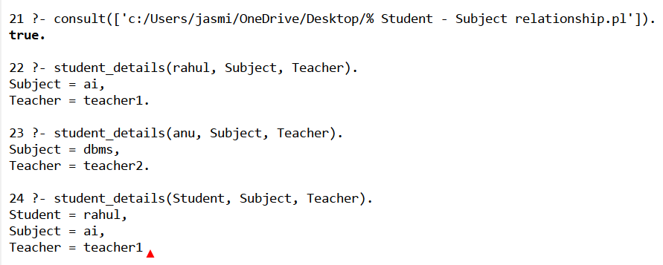RESULT
The Student-Teacher-Subject relationship program was successfully implemented in Prolog.

Program 20: Planets database

AIM
To implement a Prolog program to create a simple Planets database and store and display information such as planet name, size, and distance from the Sun.
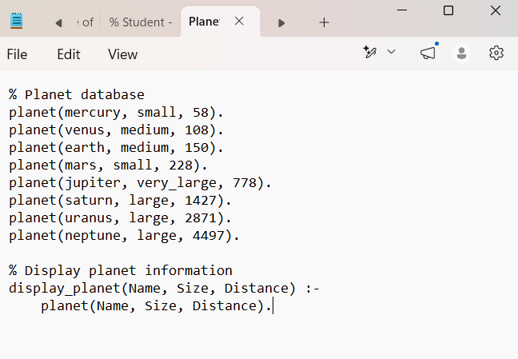
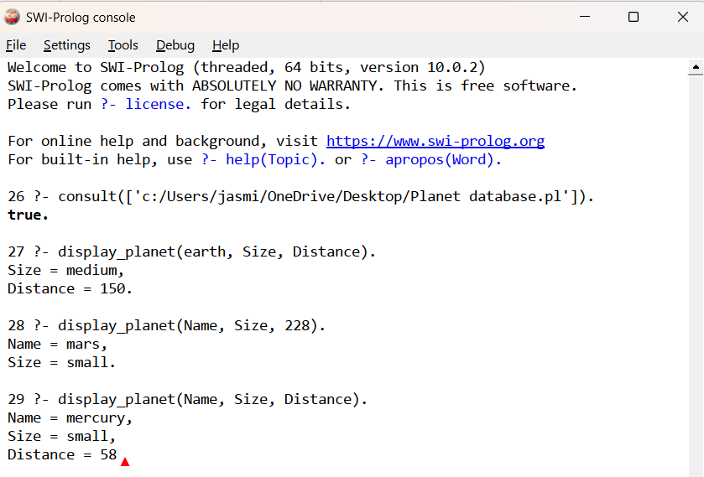

Result
Thus, the Prolog program was successfully implemented to create a Planets database and store and retrieve information about the planet name, size, and distance from the Sun.

Program 21: Tower of Hanoi problem

AIM
To implement the Tower of Hanoi problem using recursion in Python and display the sequence of moves required to transfer all disks from the source rod to the destination rod.

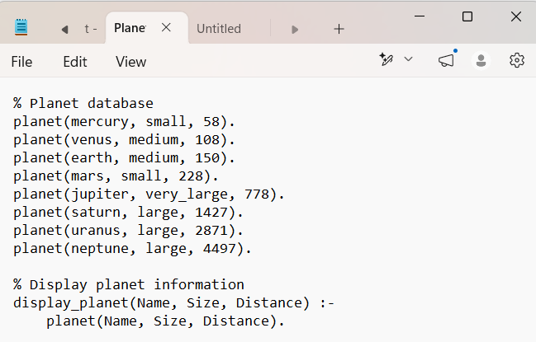
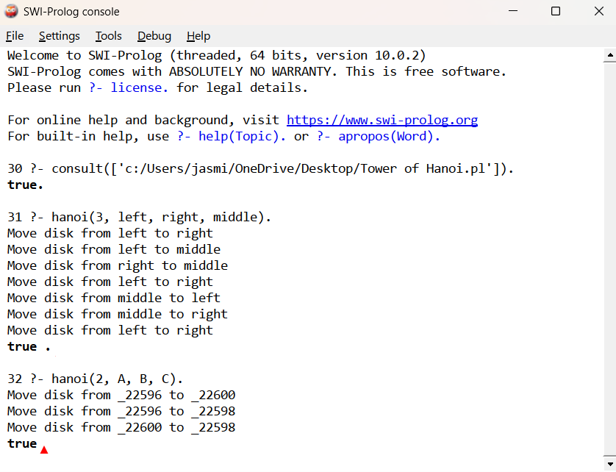

RESULT
Thus, the Tower of Hanoi problem was successfully implemented in Prolog, and the required sequence of disk movements was obtained.

Program 22:
Aim
To implement a Prolog program to determine whether a particular bird can fly or not and incorporate the required queries.
Algorithm – Bird Can Fly or Not
- Start the program.
- Define the list of birds that can fly.
- Define the list of birds that cannot fly.
- Define a rule bird_fly(Bird) to check the given bird.
- If the bird is present in can_fly, display "Bird can fly."
- If the bird is present in cannot_fly, display "Bird cannot fly."
- Give the required query with a particular bird name.
- Display the result.
- Stop the program.

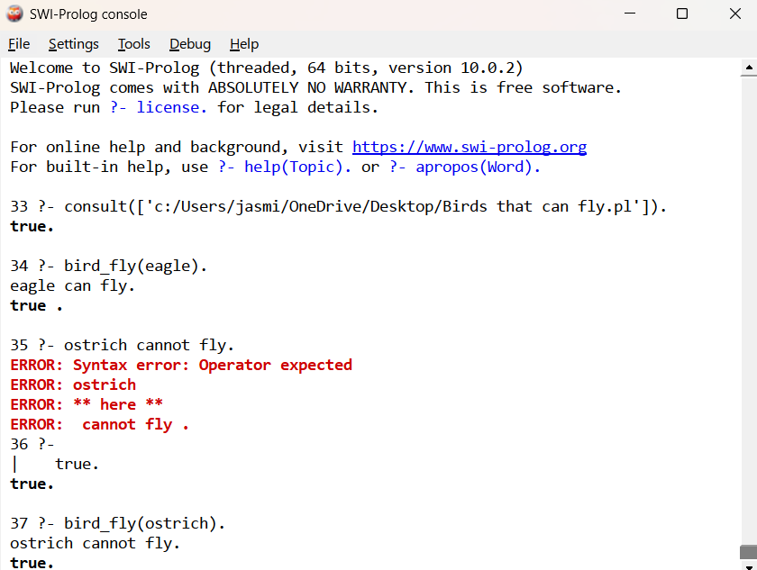

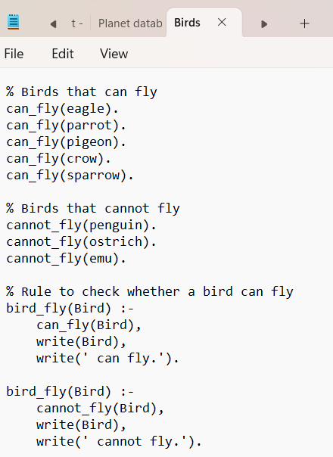

Result
Thus, the Prolog program was successfully implemented to determine and print whether a particular bird can fly or not using facts and rules.

Program 23:

Aim
To implement a Family Tree using Prolog and represent relationships such as parent, father, mother, brother, sister, and grandparent.
Algorithm
- Start the program.
- Define facts for parent, male, and female.
- Define the rule for father.
- Define the rule for mother.
- Define the rule for brother and sister.
- Define the rule for grandparent.
- Give the required query.
- Display the relationship.
- Stop.
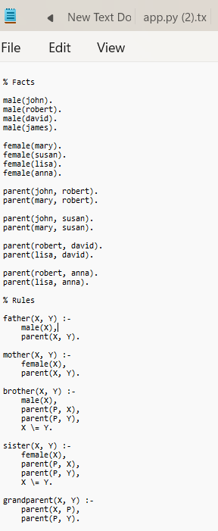
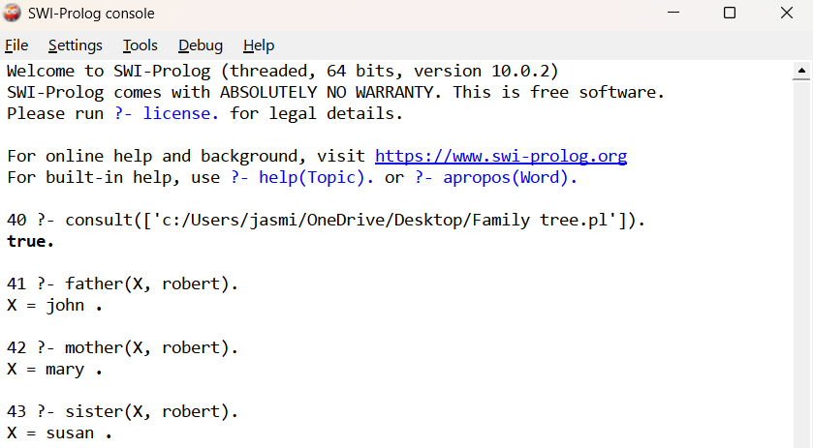

Result
Thus, the Family Tree was successfully implemented in Prolog, and the required family relationships were obtained using suitable queries.

Program 24:
Aim
To implement a Prolog program to suggest a suitable diet based on a given disease.
Algorithm
- Start the program.
- Define diseases and their recommended foods.
- Define rules to suggest a diet for each disease.
- Accept the disease as input through a query.
- Match the given disease with the corresponding diet.
- Display the recommended foods.
- Stop.
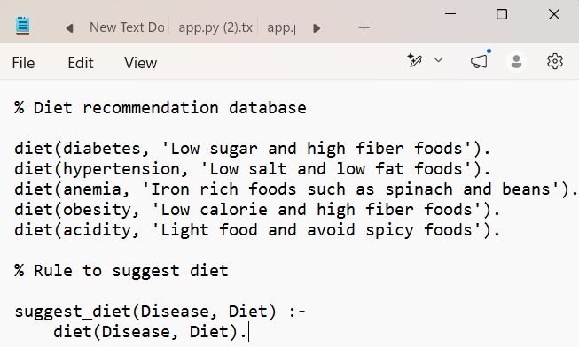
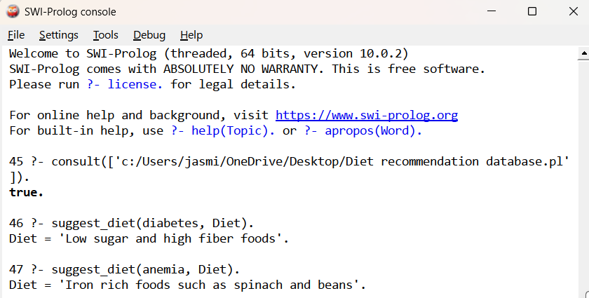

Result
Thus, the Prolog program was successfully implemented to suggest a diet based on a given disease using facts and rules.

Program 25:
Aim
To implement the Monkey Banana Problem using Prolog, where a monkey must move a box to reach the bananas hanging from the ceiling.
Algorithm
- Start the program.
- Define the initial position of the monkey, box, and bananas.
- Check whether the monkey can reach the box.
- If necessary, move the box below the bananas.
- Move the monkey onto the box.
- Check whether the monkey is below the bananas.
- If the monkey is below the bananas and standing on the box, allow it to grasp the bananas.
- Display "Monkey got the bananas."
- Stop.
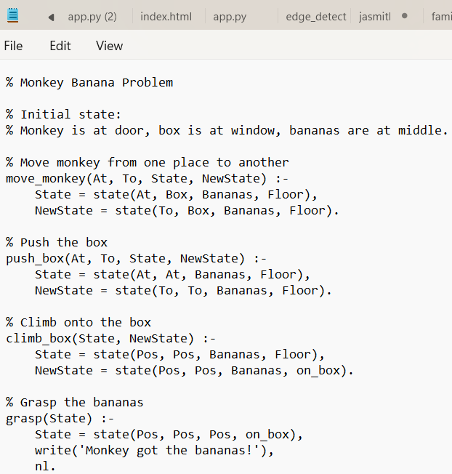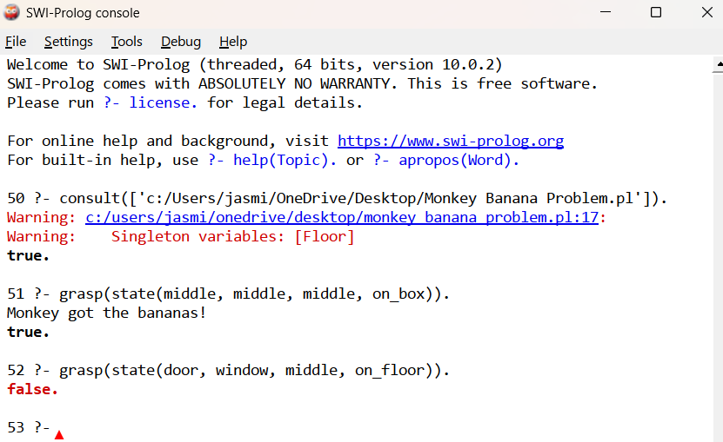

Result
Thus, the Monkey Banana Problem was successfully implemented in Prolog, and the program determines whether the monkey can obtain the bananas based on its position, the box position, and the banana position.

Program 26:
Aim
To implement a Prolog program to store fruits and their colors and display the results using backtracking.
Algorithm
- Start the program.
- Define facts containing the fruit and its color.
- Create a rule to retrieve the fruit and its color.
- Give a query with variables.
- Prolog displays the first matching fruit and color.
- Press ; to perform backtracking and get the next matching result.
- Continue until all matching facts are displayed.
- Stop.
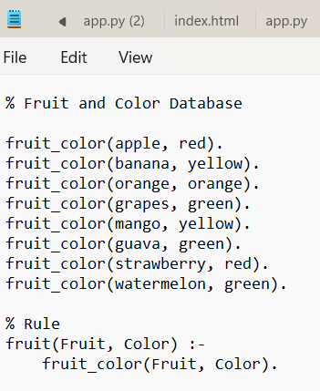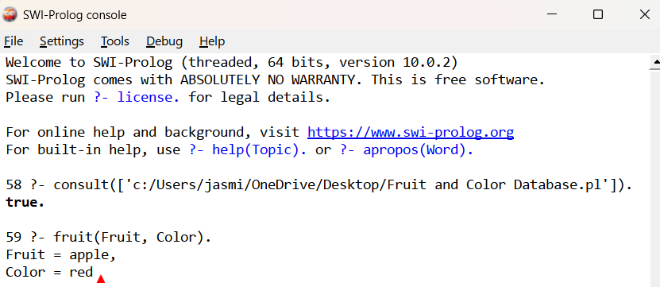

Result
Thus, the Prolog program was successfully implemented to represent fruits and their colors using facts and retrieve multiple solutions through backtracking.

Program 27:
AIM
To write and implement a Prolog program for Best-First Search algorithm to find a path from a starting node to a goal node using heuristic values.
ALGORITHM
- Start with the initial node.
- Add the initial node to the OPEN list.
- Assign heuristic values H(n) to the nodes.
- Select the node having the lowest heuristic value from the OPEN list.
- Check whether the selected node is the goal node.
- If it is the goal, stop and display the path.
- Otherwise, expand the selected node and generate its successors.
- Add the unvisited successors to the OPEN list.
- Sort the OPEN list according to heuristic values.
10.Repeat steps 4–9 until the goal is reached.
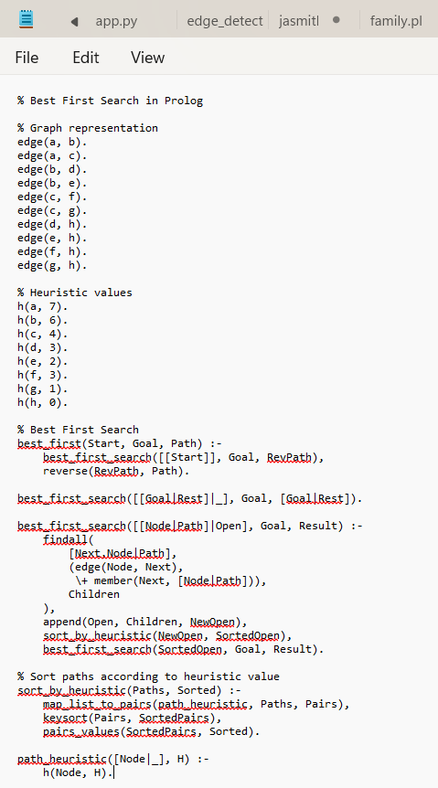

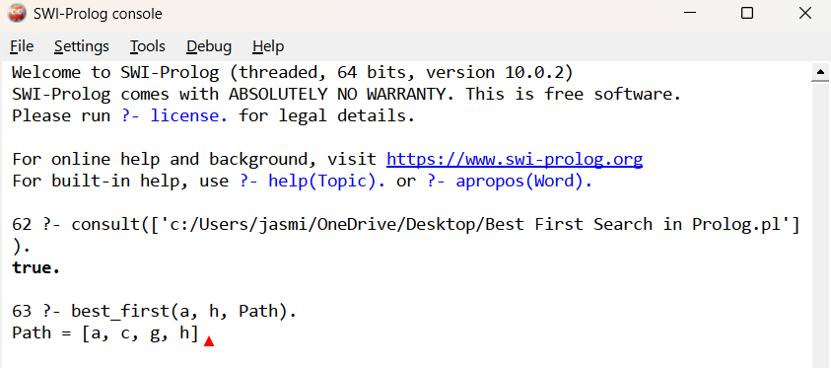

RESULT
The Best-First Search algorithm was successfully implemented in Prolog, and the optimal heuristic-based path from the starting node to the goal node was obtained.

Program 28:
AIM
To write and implement a Prolog program for medical diagnosis that identifies a possible disease based on the symptoms provided by the user.
ALGORITHM
- Start the program.
- Define diseases and their corresponding symptoms as facts/rules.
- Accept the symptoms from the user.
- Compare the given symptoms with the symptoms associated with each disease.
- If the symptoms match the conditions of a disease, identify the possible disease.
- Display the diagnosis.
- Stop the program.

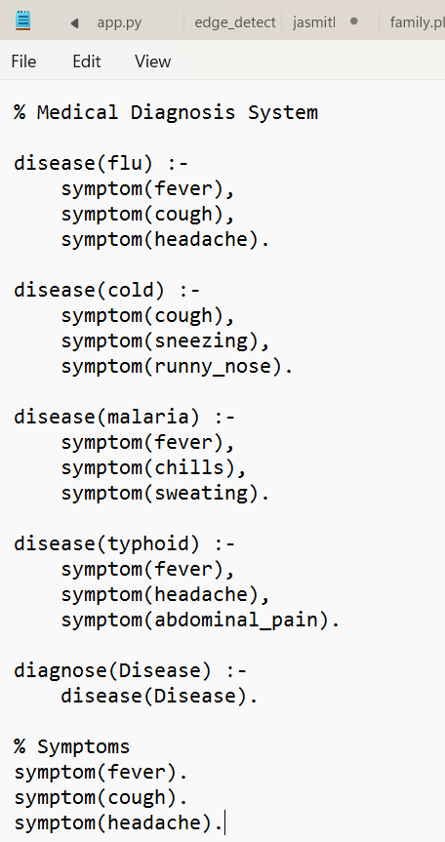
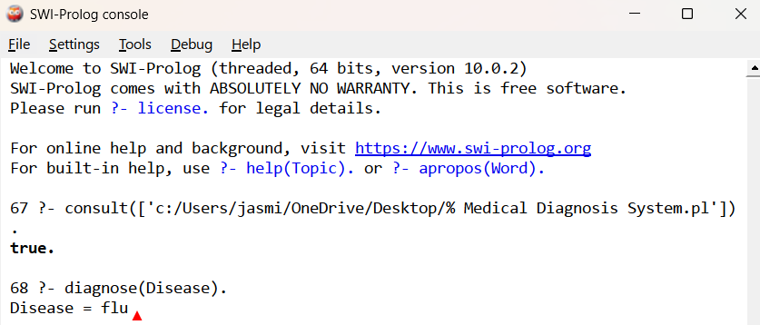

Result:
The medical diagnosis system was successfully implemented in Prolog and a possible disease was identified based on the given symptoms.

Program 29:
AIM
To write and implement a Prolog program for Forward Chaining and incorporate the required queries to derive new facts from existing facts and rules.
ALGORITHM
- Start with a set of known facts.
- Define rules using the known facts.
- Check whether the conditions of any rule are satisfied.
- If satisfied, derive a new fact.
- Add the new fact to the knowledge base.
- Repeat the process until no new facts can be derived.
- Execute the required queries to verify the derived facts.
- Stop.
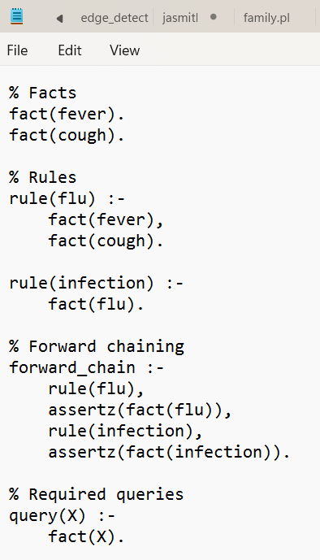

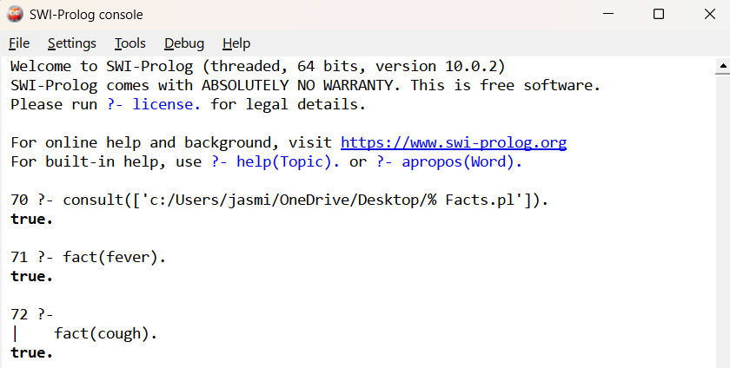

RESULT
Thus, the Forward Chaining algorithm was successfully implemented in Prolog, and the required queries were executed to derive new facts from the given knowledge base.

Program 30:
AIM
To write and implement a Prolog program for Backward Chaining and execute the required queries to prove a goal using the available facts and rules.
ALGORITHM
- Start with a goal to be proved.
- Search for a rule whose conclusion matches the goal.
- Treat the conditions of that rule as sub-goals.
- Check whether each sub-goal can be proved using facts or other rules.
- Continue recursively until the required facts are found.
- If all sub-goals are satisfied, the original goal is proved.
- Execute the required queries and display the result.
- Stop.

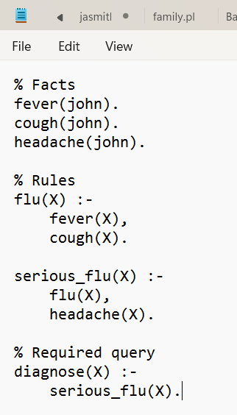
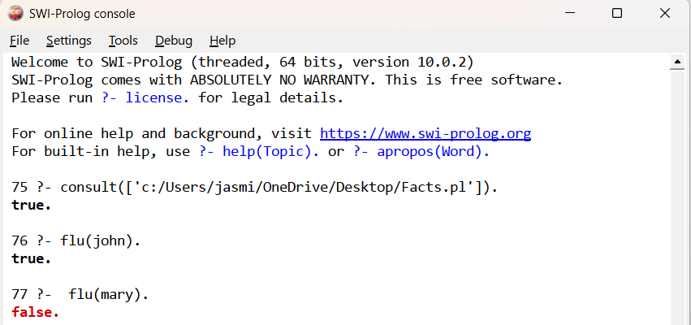

RESULT
Thus, the Backward Chaining algorithm was successfully implemented in Prolog, and the required queries were executed successfully to prove the given goals from the available facts and rules.
Program 31:
AIM
To write and implement a Prolog program for Pattern Matching and execute the required queries to match given patterns with facts.
ALGORITHM
- Start the program.
- Define facts containing different patterns.
- Define a rule to match the given pattern with the facts.
- Use Prolog variables to find matching values.
- Execute the required queries.
- Display the matched result.
- Stop.

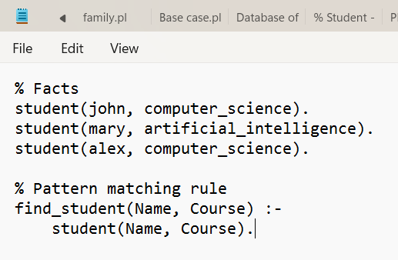
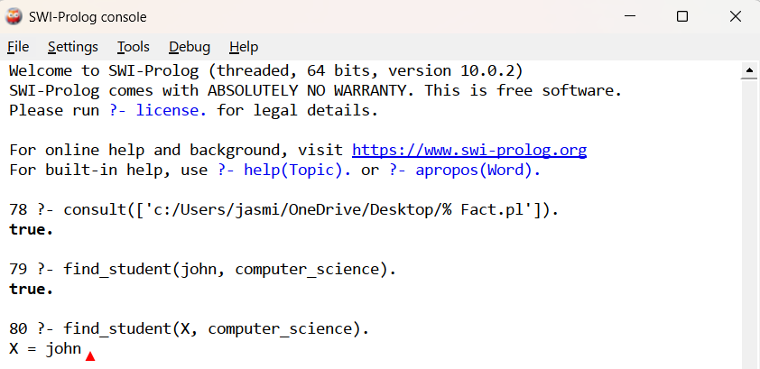

RESULT
Thus, the Pattern Matching program was successfully implemented in Prolog, and the required queries were executed to obtain the matching values.

Program 32:
AIM
To write and implement a Prolog program to find the number of vowels in a given string.
ALGORITHM
- Start the program.
- Read a string as input.
- Check each character of the string.
- If the character is a vowel (a, e, i, o, u), increment the count.
- Continue until all characters are checked.
- Display the total number of vowels.
- Stop.

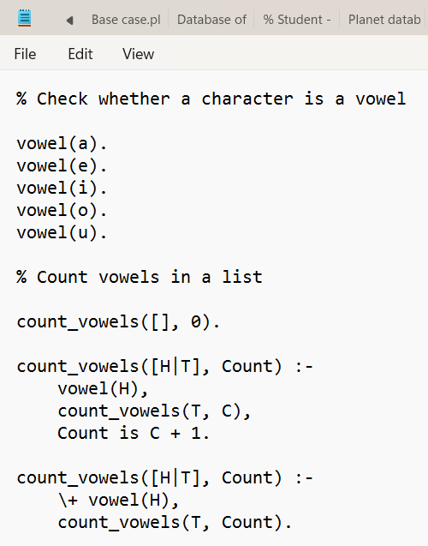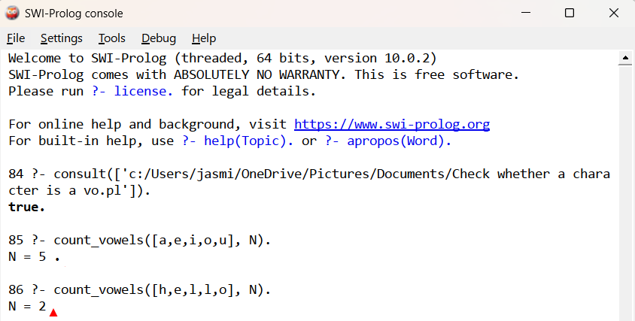

RESULT
Thus, the Prolog program to find the number of vowels in a given list was successfully implemented, and the number of vowels was obtained correctly.

Program 33:

